There are 5 tables in total in the current stage of the project.

Table 1: house_unit

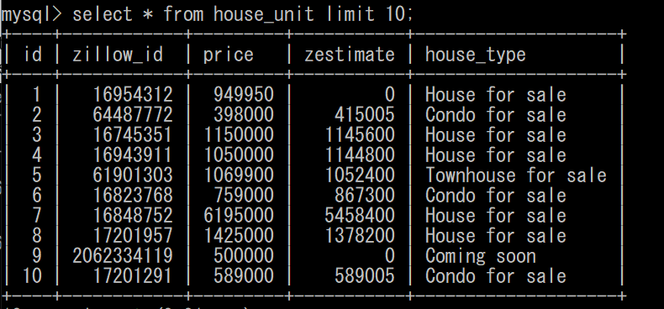

Table 2: unit_info:

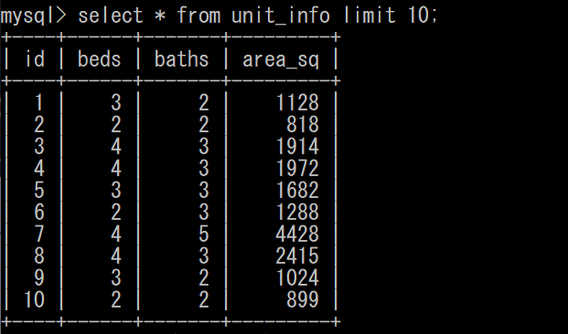

Table 3: unit_address:

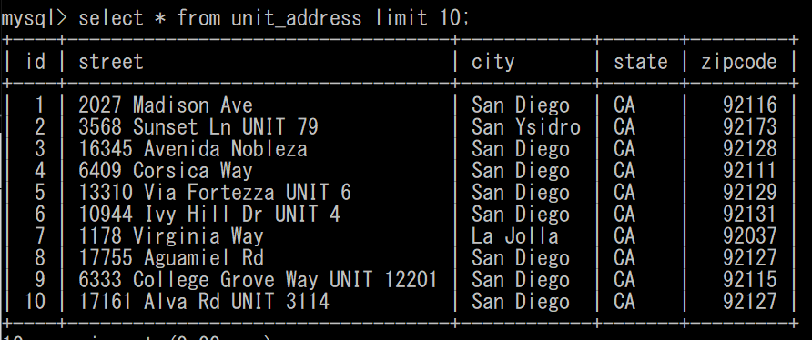

Table 4: unit_image:

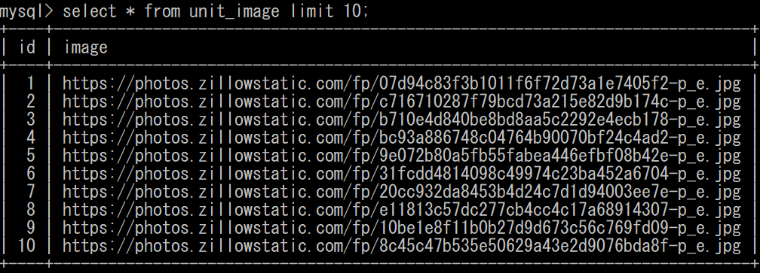

Table 5: unit_link:

